### **1. How to Access the Account Payment?**

To view the Account Payment screen, you can either:

* Search for "Account Payment" using the search bar, or
* Navigate through the menu: Menu → Billing → Account Payment.

### **2. What is the Usage of Account Payment?**

From the Account Payment screen, you can:

* Reconcile payments for self-pay prescriptions and the Patient Responsible Amount (copay) received from insurance.
* Create receipts for credit amounts on the accounts.

### **3. How to create Account Payment Receipts?**

In the Account field, a list of accounts will be displayed along with phone number and address details.

* If the account is for a system patient, a "P" badge will appear before the account’s name.
* If the account is for a contact person (created from the Contact Master), a "C" badge will appear before the account’s name.

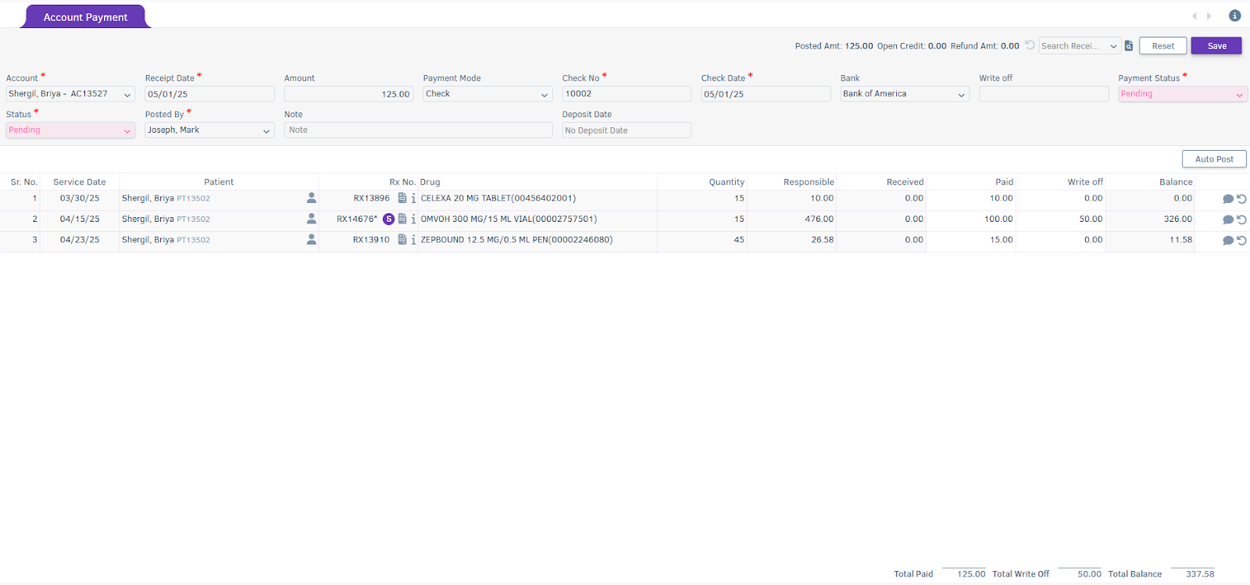

* If the account is for a facility, an "F" badge will appear before the account’s name.

Upon selecting an account (responsible for the bill), prescription details such as Bill Service Date, Patient, Rx No, Drug, Total Bill Quantity, Responsible Amount, and Received Amount to date will automatically populate and be displayed in the grid.

Note:  
If no prescription is pending to reconcile against the account, an alert “No Pending Bills” will be shown.

Enter the payment details at the Receipt header level, including Paid Amount and Write-off Amount for the prescription. Finally, click Save at the top right of the screen to create the Account Payment receipt.

### **4. What Indications Are Displayed in the Rx No. Field?**

* If the prescription has not been verified, an asterisk will appear next to the Rx No.
* If the prescription(s) is billed under a Self-Pay or Charged account, an "S" badge will appear next to the Rx No.
* To open a bill, click the 
* icon located next to the Rx No.
* To view the patient ledger, click the 
* icon next to the Rx No.

### **5. How to Auto-Post Receipts?**

* To enable the Auto Post feature, check the "Auto-Reconcile during Account Payment" option under the Billing section in the Client Settings screen.



* Once Auto-Reconcile during Account Payment is enabled, the Paid amount and Write-off amount are automatically set against the prescription, starting from sequence number 1.

Note:

* When Auto-Reconcile during Account Payment is unchecked, you can manually auto-post the Paid and Write-off amounts by clicking the Auto Post button located at the top-right corner of the grid.

### **6. How the system applies Paid and Write-off amounts to the prescription(s)?**

The first payment is applied to the Rx. If the receipt amount is applied to the prescription but a balance remains, the system will begin to adjust the write-off amount against the prescription.

### **7. How is an Account Payment Receipt Created via Online Payment Transaction Mode?**

* For online payment methods like Credit Card, Debit Card, or FSA/HSA card, enter the amount, then select the payment mode. The payment modal will appear upon selection of the payment mode. Choose the transaction type (either Swipe or Manual) and select the payment gateway account. Click Make Payment to complete the online transaction.
* When a payment is made by the account through an online transaction, such as a credit card, debit card, or FSA/HSA payment, the following details will be disabled:
  + Account
  + Receipt Date
  + Amount
  + Payment Mode
  + Payment No
  + Payment Date
* You cannot delete the Account Payment receipt created via an online transaction.

### **8. What are the Features of Account Payment Receipt?**

1. **Search Account Receipt:**
   * You can search for an account receipt by clicking on the search icon present on the top right side of the receipt.
     1. If an account is already selected in the Account Payment screen, only the existing receipts for that account will be displayed in the Payment Transaction Tracking modal.
     2. If no account is selected in the Account Payment screen, all existing receipts for all accounts will be displayed in the same modal.
2. **Open existing receipt from "Search Receipt” field present on Account Payment screen:**
   * You can open an existing receipt by using the "Search Receipt" field available in the Account Payment screen.

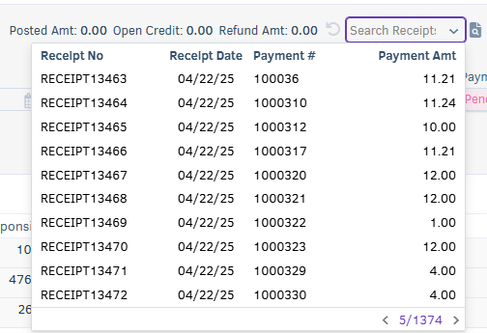

1. **Print Receipt:**
   * You can print an Account Payment receipt by clicking on the view Receipt icon present on the top right side

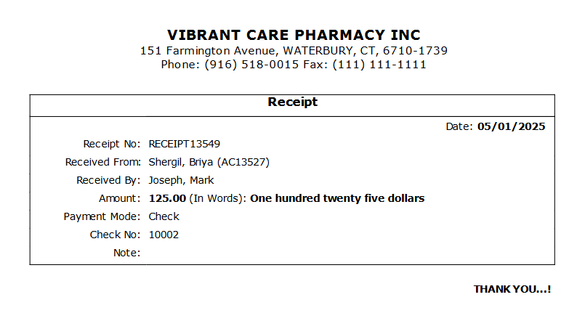

1. **Summary present at Bottom Level:**

* You can view the Total Paid amount, Total Write-off amount, and Total Balance for the services present in the receipt.

